3.0 Conceptual & Logical Database Design - Normalization

Y&J Shuttle Service's raw data really comes from two paper/spreadsheet sources: the vehicle logbook, and the payment records (bank statement checked against an Excel sheet). The Scholar, Parent, School and Route details are not written on one single paper form today — they come from the business rules and data requirements gathered in Section 2. All of this is combined below into one Master Unnormalized Relation (UNF) so the source of every attribute is clear before normalization starts, and so the functional dependencies used in 1NF, 2NF and 3NF can be shown consistently.

Master Unnormalized Relation (UNF):
YJ_TRANSPORT_DATA(
LogEntryID, TripDate, TripTime, VehicleRegNo, VehicleType, VehicleCapacity, VehicleStatus,
DriverName, DriverContact, DriverEmploymentStatus, DriverManager,
OpeningKm, ClosingKm, TotalBusinessKm, TotalPersonalKm, To, From, Reason,
RoutePickupArea, RouteDistance, RouteMonthlyFee,
ScholarFirstName, ScholarLastName, PickupAddress, DropoffAddress, ScholarStatus, PickupConfirmed, DropoffConfirmed,
ParentName, ParentPhone, ParentEmail,
SchoolName, SchoolLocation,
FuelCost, MaintenanceCost, MaintenanceType, MaintenanceDescription,
PermitNo, PermitIssueDate, PermitExpiry,
PaymentDate, PaymentAmount, PaymentMethod, PaymentReference, PaymentStatus,
AttendanceDate, AttendanceStatus, TimeIn, TimeOut,
ScholarRouteStartDate, ScholarRouteEndDate,
DriverRouteStartDate, DriverRouteEndDate)
The Master UNF combines the attributes needed for the final schema. The vehicle logbook provides information relating to trips, mileage, travel details, fuel and maintenance, while information about scholars, parents, schools and routes is obtained through the scholar registration and transport processes. Payment information is also included based on the recording of payments
DriverManager is added because the Driver table's MANAGER_ID shows who each driver reports to.

3.1 Unnormalized Form (UNF)
The table below shows the raw Y&J vehicle logbook exactly as currently recorded on paper, with no key.

Vehicle Log Entry (Raw Logbook)

DATE | TIME | OPENING_KM | CLOSING_KM | TOTAL_BUSINESS_KM | TOTAL_PERSONAL_KM | BUSINESS_TRAVEL_  DETAIL |  |  | FUEL & OIL COST | REPAIRS & MAINTENANCE COST
 |  |  |  |  |  | To | From | Reason
Table 3.1: Vehicle Log Entry - Unnormalized Form (UNF)

3.2 First Normal Form (1NF)

The raw logbook has two main problems. First, the “Business Travel Details” field contains three separate pieces of information: To, From, and Reason. Second, there is no field that uniquely identifies each log entry.

To achieve 1NF, the travel details are separated into individual fields, and LOG_ENTRY_ID is introduced as the primary key. VEHICLE_ID and DRIVER_ID are included as foreign keys so that each log entry can be linked to the correct vehicle and driver.

1NF dependency:
LOG_ENTRY_ID → TripDate, TripTime, VehicleID, DriverID, OpeningKm, ClosingKm, TotalBusinessKm, TotalPersonalKm, To, From, Reason, Fuel & Oil Cost, Repairs & Maintenance Cost

Because LOG_ENTRY_ID is a single-column primary key, there are no partial dependencies in the Vehicle Log Entry relation.
Vehicle Log Entry (1NF)

LOG_ENTRY_ID  PK | VEHICLE_ID  FK | DRIVER_ID  FK | TRIP_DATE | TRIP_TIME | OPENING_  KM | CLOSING_  KM | TOTAL_  BUSINESS_KM | TOTAL_PERSONAL_KM | TO | FROM | REASON | FUEL & OIL COST | REPAIRS & MAINTENANCE COST
Table 3.2: Vehicle Log Entry - First Normal Form (1NF)

3.3 Second Normal Form (2NF)
2NF removes partial dependencies caused by composite keys. In the conceptual trip-scholar relation, the composite key is (LOG_ENTRY_ID, SCHOLAR_ID).
Scholar-specific attributes depend only on SCHOLAR_ID, while trip-specific attributes depend only on LOG_ENTRY_ID.
The many-scholars-per-trip relationship is therefore resolved by separating Scholar and introducing the TripScholar junction table.
Functional dependencies (X → Y means X determines Y) that justify the 2NF split:
[LOG_ENTRY_ID, SCHOLAR_ID] → PickupConfirmed, DropoffConfirmed (full dependency on the complete composite key).
SCHOLAR_ID → ScholarFirstName, ScholarLastName, PickupAddress, DropoffAddress, ScholarStatus, ParentID, SchoolID (partial dependency in the combined trip-scholar relation; these attributes depend only on SCHOLAR_ID).
LOG_ENTRY_ID → TripDate, TripTime, OpeningKm, ClosingKm, VehicleID, DriverID, To, From, Reason (partial dependency in the combined trip-scholar relation; these attributes depend only on LOG_ENTRY_ID).

Vehicle Log Entry (2NF)
The Vehicle Log Entry table stores information about each vehicle trip.
The table uses LOG_ENTRY_ID as its primary key, so there are no partial dependencies.

LOG_ENTRY_  ID  PK | VEHICLE_ID  FK | DRIVER_ID  FK | TRIP_DATE | TRIP_TIME | OPENING_KM | CLOSING_KM | TOTAL_BUSINESS_KM | TOTAL_PERSONAL_KM | TO | FROM | REASON | FUEL & OIL COST | REPAIRS & MAINTENANCE COST
Table 3.3: Vehicle Log Entry - Second Normal Form (2NF)

Scholar
The Scholar table stores information that identifies each scholar, including their first and last name, parent and school details, and pickup and drop-off locations.

SCHOLAR_ID  PK | FIRST_NAME | LAST_NAME | STATUS | PARENT_ID  FK | SCHOOL_ID  FK | PICKUP_LOCATION | DROPOFF_LOCATION
Table 3.4: Scholar - Second Normal Form (2NF)

TripScholar (Junction Table)
The TripScholar table links scholars to vehicle log entries and records whether their pickup and drop-off were confirmed for each trip.

LOG_ENTRY_ID  PK,FK | SCHOLAR_ID  PK,FK | PICKUP_CONFIRMED | DROPOFF_CONFIRMED
Table 3.5: TripScholar (Junction Table) - Second Normal Form (2NF)

3.4 Third Normal Form (3NF)
3NF removes transitive dependencies: non-key descriptive attributes are stored with the entity they describe rather than being repeated in a transaction table. The final design contains 15 normalized tables.

Key transitive dependencies removed:
SCHOLAR_ID → PARENT_ID and PARENT_ID → ParentName, PhoneNo, Email (Parent is separated).
SCHOLAR_ID → SCHOOL_ID and SCHOOL_ID → SchoolName, Location (School is separated).
LOG_ENTRY_ID → VEHICLE_ID and VEHICLE_ID → RegistrationNo, Type, Capacity, Status (Vehicle is separated).
LOG_ENTRY_ID → DRIVER_ID and DRIVER_ID → Name, ContactDetails, EmpStatus, (Driver is separated).
LOG_ENTRY_ID → ROUTE_ID and ROUTE_ID → PickupArea, SchoolID, Distance, MonthlyFee (Route is separated and takes over from the To/From text). REASON is not kept, because it is not one of the Trip fields listed in Section 2.3 — To and From are now shown through ROUTE_ID instead.
Additional entity-level dependencies are also represented directly in their final tables: VEHICLE_ID → vehicle attributes; DRIVER_ID → driver attributes; PARENT_ID → parent attributes; SCHOOL_ID → school attributes; ROUTE_ID → route attributes; and PAYMENT_ID / ATTENDANCE_ID / PERMIT_ID identify their respective records.

Vehicle Log Entry
Stores the details of each vehicle trip or log entry, including the trip date and time, vehicle, driver, route, and mileage information. Vehicle and driver details are kept in their own tables to remove transitive dependencies.

LOG_ENTRY_ID  PK | VEHICLE_ID  FK | DRIVER_ID  FK | ROUTE_ID  FK | TRIP_DATE | TRIP_TIME | OPENING_KM | CLOSING_KM | TOTAL_BUSINESS_KM | TOTAL_PERSONAL_KM
Table 3.6: Vehicle Log Entry - Third Normal Form (3NF)

Fuel Expense
Stores fuel and oil expenses for each vehicle by date. These expenses are separated from the trip table because the cost depends on the vehicle and date rather than on a specific trip.

EXPENSE_ID  PK | VEHICLE_ID  FK | DATE | COST
Table 3.7: Fuel Expense - Third Normal Form (3NF)

Vehicle Maintenance
Stores maintenance and repair records for each vehicle, including the maintenance date, type, cost, and description. This keeps vehicle maintenance information separate from individual trip records.

MAINTENANCE_ID  PK | VEHICLE_ID  FK | DATE | TYPE | COST | DESCRIPTION
Table 3.8: Vehicle Maintenance - Third Normal Form (3NF)

Driver
Stores the identifying and employment information for each driver, including their contact details and employment status. Driver information is separated from vehicle log entries because it depends on DRIVER_ID.

DRIVER_ID  PK | MANAGER_ID  FK | NAME | CONTACT_DETAILS | EMP_STATUS
Table 3.9: Driver - Third Normal Form (3NF)

Vehicle
Stores the identifying and descriptive information for each vehicle, including registration number, vehicle type, capacity, and status. This prevents vehicle details from being repeatedly stored in trip records.

VEHICLE_ID  PK | REGISTRATION_NO | TYPE | CAPACITY | STATUS
Table 3.10: Vehicle - Third Normal Form (3NF)

Parent
Stores the contact information for each scholar's parent or guardian. Parent details are separated from the Scholar table because they depend on PARENT_ID rather than SCHOLAR_ID.

PARENT_ID  PK | NAME | PHONE_NO | EMAIL
Table 3.11: Parent - Third Normal Form (3NF)

School
Stores information about each school, including its name and location. School details are separated from the Scholar table because they depend on SCHOOL_ID.

SCHOOL_ID  PK | NAME | LOCATION
Table 3.12: School - Third Normal Form (3NF)

Scholar
Stores information identifying each scholar, including their first and last name, pickup and drop-off locations, and references to their parent and school. Parent and school details are stored separately to remove transitive dependencies.

SCHOLAR_ID  PK | SCHOOL_ID  FK | PARENT_ID  FK | FIRST_NAME | LAST_NAME | STATUS | PICKUP_LOCATION | DROPOFF_LOCATION
Table 3.13: Scholar - Third Normal Form (3NF)

Payment
Stores payment records made in relation to a parent, including the payment date, amount, method, reference, and status. Payment information is maintained separately because a payment is a separate transaction and is not dependent on a particular trip.

PAYMENT_ID  PK | PARENT_ID  FK | DATE | AMOUNT | METHOD | REFERENCE | STATUS
Table 3.14: Payment - Third Normal Form (3NF)

Attendance
Stores attendance records for drivers, including the attendance date, status, time in, and time out. Attendance is separated from trip records because it represents driver attendance rather than a vehicle trip.

ATTENDANCE_ID  PK | DRIVER_ID  FK | DATE | STATUS | TIME_IN | TIME_OUT
Table 3.15: Attendance - Third Normal Form (3NF)

Vehicle Permit
Stores permit and licensing information for vehicles, including the permit number, issue date, and expiry date. Permit information is separated from the Vehicle table because a vehicle can have separate permit records.

PERMIT_ID  PK | VEHICLE_ID  FK | PERMIT_NO | ISSUE_DATE | EXPIRY_DATE
Table 3.16: Vehicle Permit - Third Normal Form (3NF)

Route
Stores reusable route information linked to a school, including the pickup area, route distance, and monthly fee. Keeping route information separately avoids repeating the same route details for multiple scholars or drivers.

ROUTE_ID  PK | SCHOOL_ID  FK | PICKUP_AREA | DISTANCE | MONTHLY_FEE
Table 3.17: Route - Third Normal Form (3NF)

Scholar Route Assignment
Links scholars to the routes to which they are assigned and records the period of the assignment using start and end dates. This junction table resolves the relationship between scholars and routes.

SCHOLAR_ID  PK,FK | ROUTE_ID  PK,FK | START_DATE | END_DATE
Table 3.18: Scholar Route Assignment - Third Normal Form (3NF)

Driver Route Assignment
Links drivers to the routes to which they are assigned and records the period of each assignment using start and end dates. This junction table resolves the relationship between drivers and routes.

DRIVER_ID  PK,FK | ROUTE_ID  PK,FK | START_DATE | END_DATE
Table 3.19: Driver Route Assignment - Third Normal Form (3NF)

Y&J Shuttle Service ERD
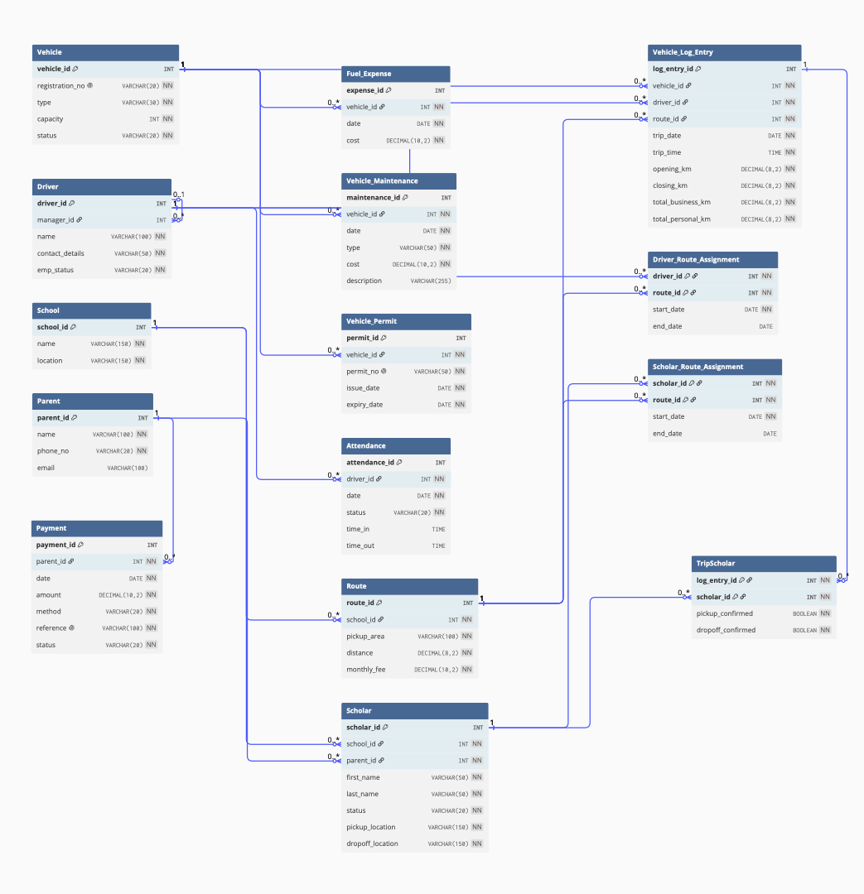
Figure 1: Y&J Shuttle Service Entity Relationship Diagram (Crow's Foot Notation, with cardinality)

